Step 1: Data binding with string variables:

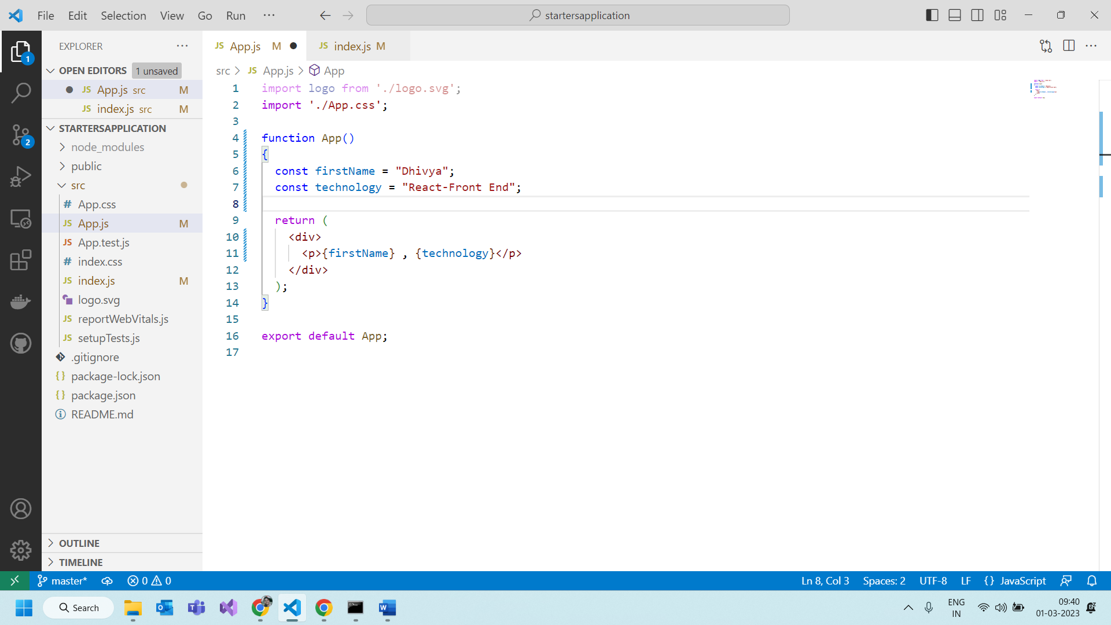

Trying to display the data based on condition

Condition false.

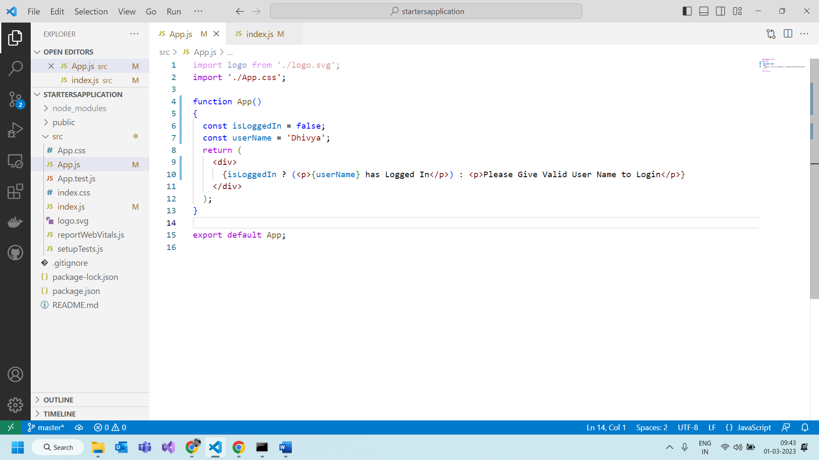

The output will be :

Condition is true:

Output:

Creating another functional component

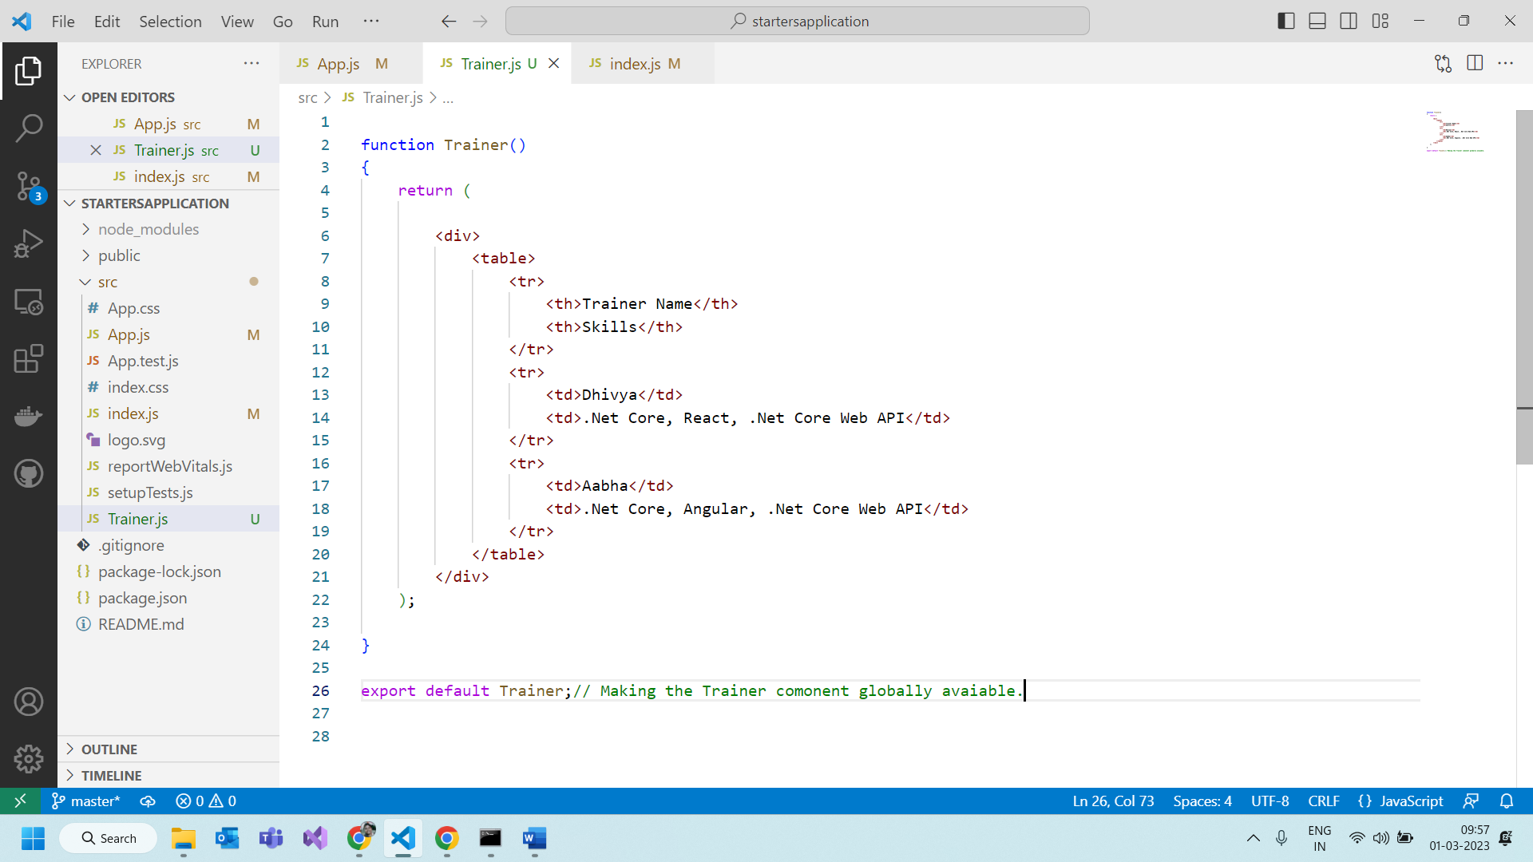

Function Component with input parameters:

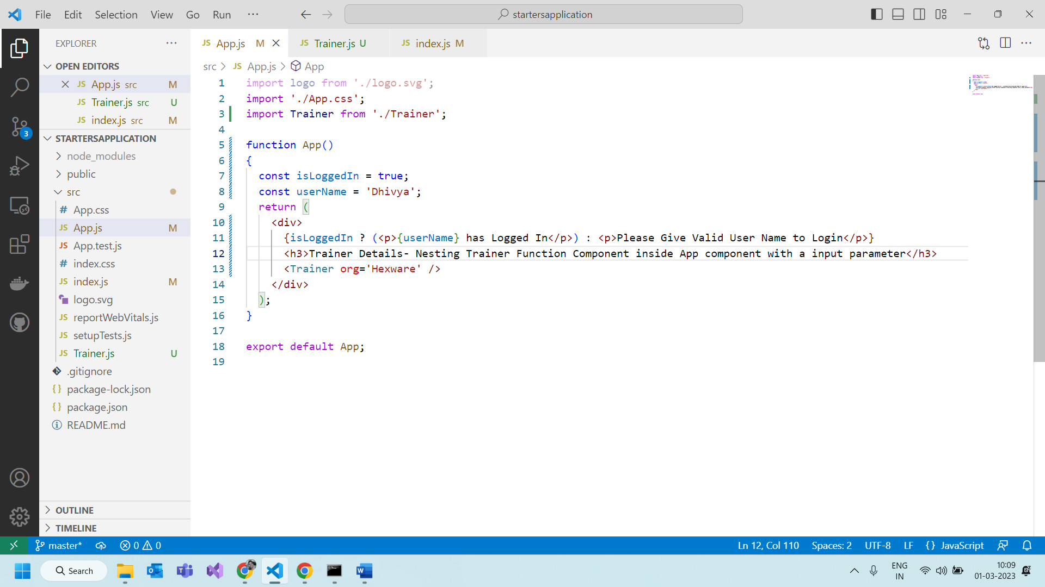

In trainer.js file:

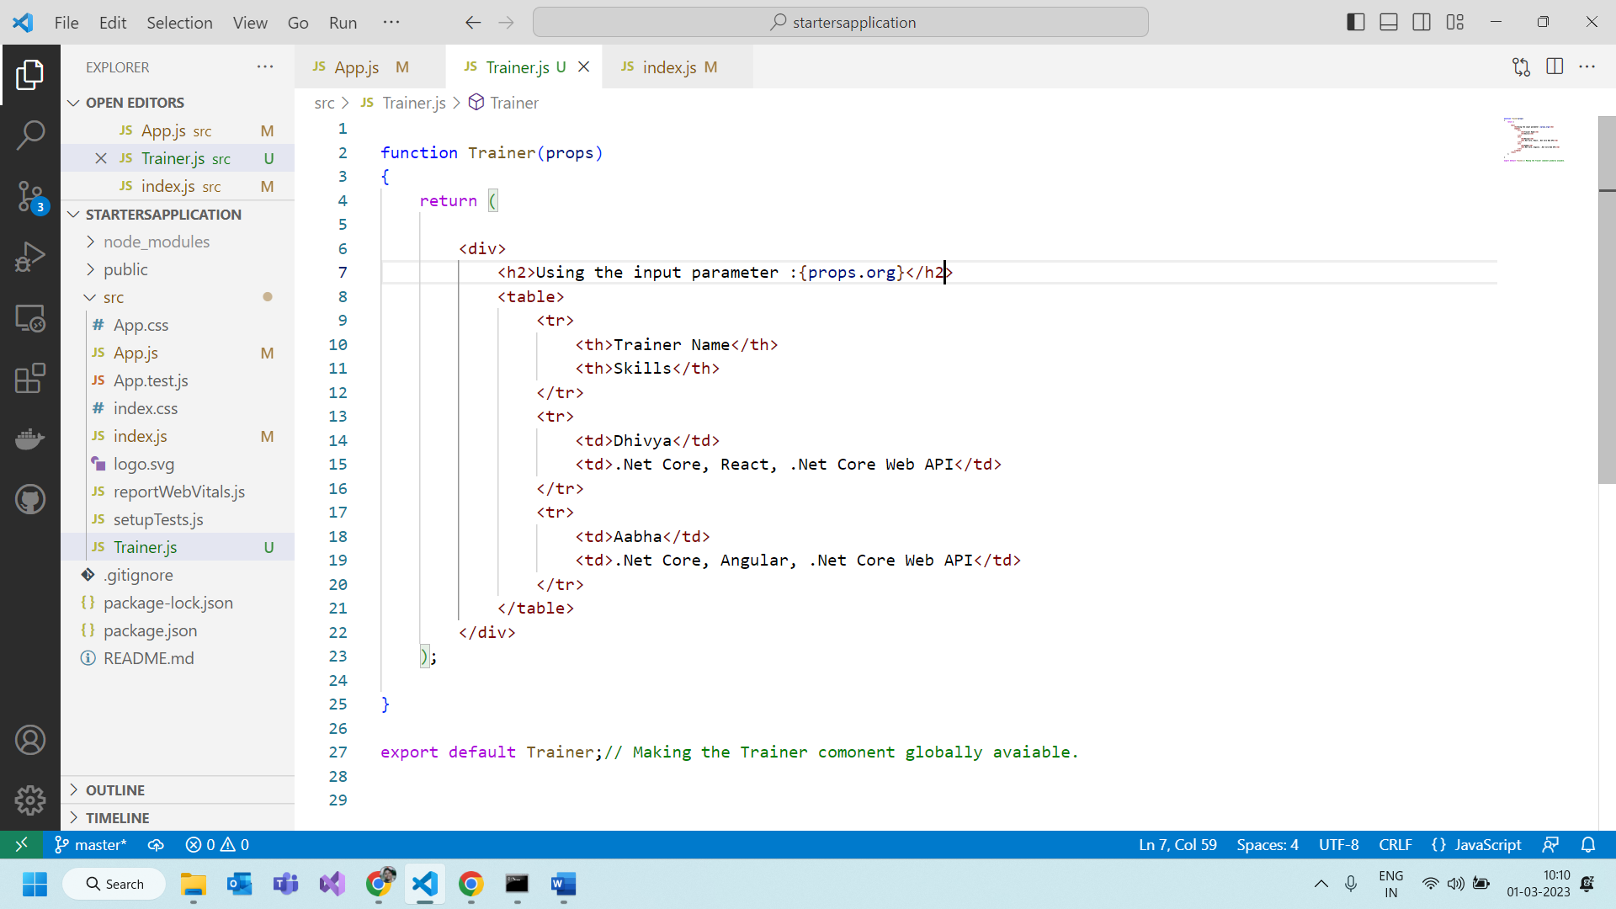

Creating function using Arrow functions

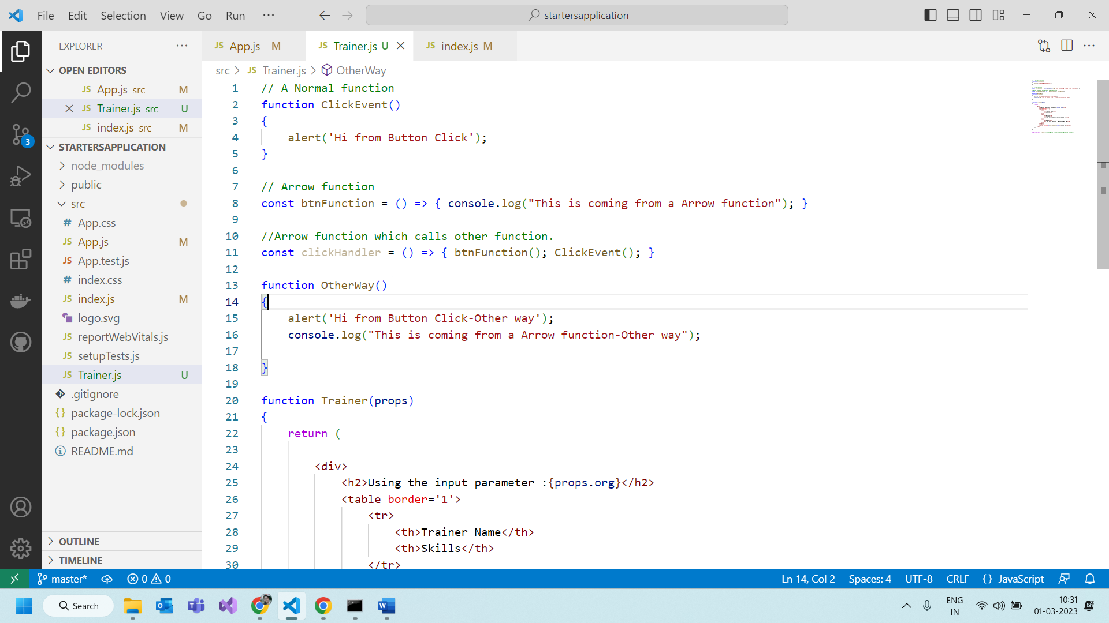

Event binding in react

